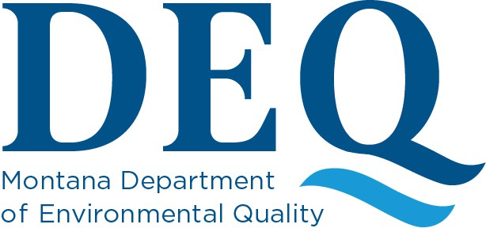

Guidance Document to Determine Applicability of Residential Exemption
40 CFR §61.141 - Facility means any institutional, commercial, public, industrial, or residential structure, installation, or building (including any structure, installation, or building containing condominiums or individual dwelling units operated as a residential cooperative but excluding residential buildings having four or fewer dwelling units); any ship; and any active or inactive waste disposal site. For purposes of this definition, any building, structure, or installation that contains a loft used as a dwelling is not considered a residential structure, installation, or building. Any structure, installation or building that was previously subject to this subpart is not excluded, regardless of its current use or function.
40 CFR §61.141 – Installation means any building or structure or any group of buildings or structures at a single demolition or renovation site that are under the control of the same owner or operator (or owner or owner operator under common control)

To determine if the Residential Exemption applies to your project, answer the following questions.
- Is the structure a single residential building having four or fewer units that does not meet the definition of an “installation”? If No -the RE does not apply, If Yes -Go to question 2

- Is the structure the only structure impacted by the proposed renovation/demolition within 660 feet (roughly a city block) that is under the control of the same owner or operator? If No -the RE does not apply, If Yes -Go to question 3

- Are there definitive plans (through written or verbal means) with the intention of adopting those plans, to include the site in an institutional, commercial, public, or industrial project including the use of the structure for a fire service training exercise? If Yes -The RE does not apply, If No -Go to question 4

- Regardless of the current use of the structure, is the structure currently or was it previously used for commercial, industrial, or other non-residential use that would be subject to the federal asbestos NESHAP and/or Montana Asbestos Control Act? If YES - The RE does not apply, If No-RE applies
Brought to you by the Department of Environmental Quality’s Asbestos Control Program
If you need additional assistance with determining a structures eligibility for Residential Exemption. Please contact the Department of Environmental Quality’s Asbestos Control Program at: 406-444-5300 (office) or Email: deqacponline@mt.gov

Greg Gianforte, Governor I Sonja Nowakowski, Director I P.O. Box 200901 I Helena, MT 59620-0901 I (406) 444-2544 I www.deq.mt.gov

